**Based on Performance and micro-controller it is divided into 3 types as follows :**

1. **Small Scale Embedded Systems :**Small Scale Embedded Systems are designed using an 8-bit or 16-bit micro-controller. They can be powered by a battery. The processor uses very less/limited resources of memory and processing speed. Mainly these systems does not act as an independent system they act as any component of computer system but they did not compute and dedicated for a specific task. Example of small scale

#### **Washing Machine**

* Machines have a microcontroller which is for controlling all the tasks.
* Sensors and actuators are best level sensors, motor, and also a display and a better keypad to input information are some of the examples!
* Once you load clothes in the machine, the whole process consists of three cycles. Washing, rinsing, and spinning!
* Small Scale Embedded System.

**Medium Scale Systems** 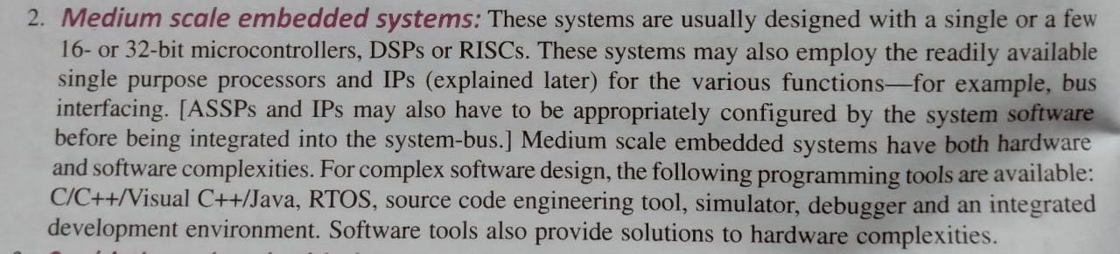

**Automatic Teller machine: ATM includes embedded systems to detect the card, a communication interface between the bank, and the output to give money. All these procedures are done with microcontrollers.**

**Sophisticated Systems:**

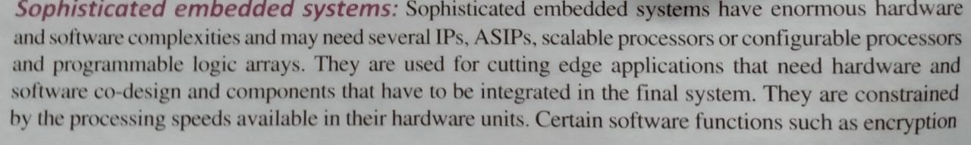

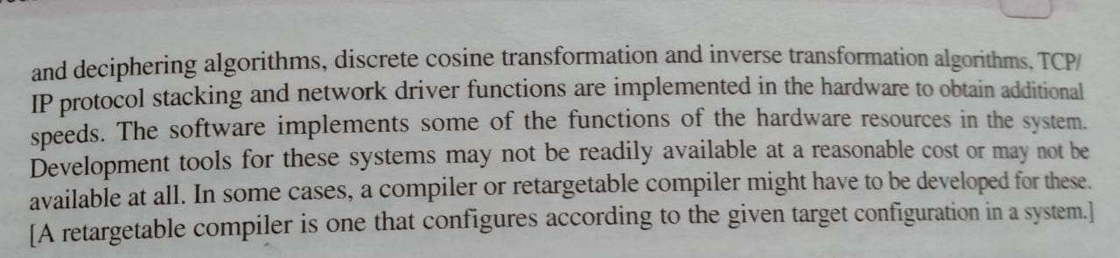

**Components of Embedded systems**

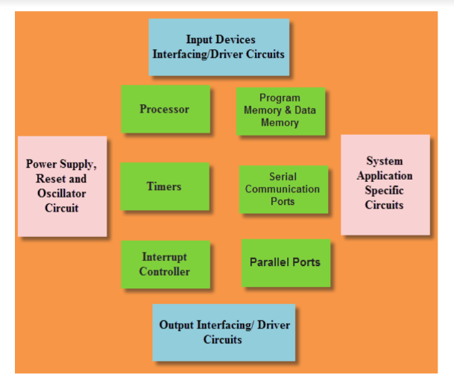

**Power:** 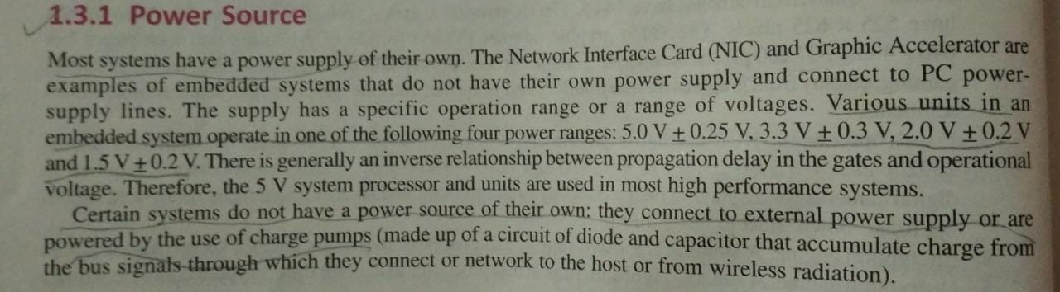

**Clock Circuits**

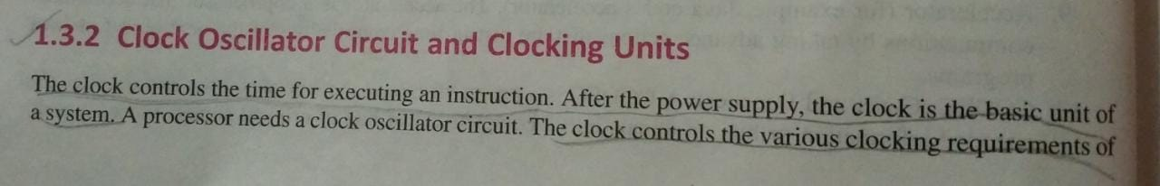

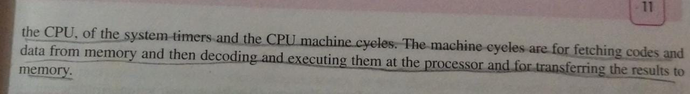



**System Timers and Real TIme Clocks**

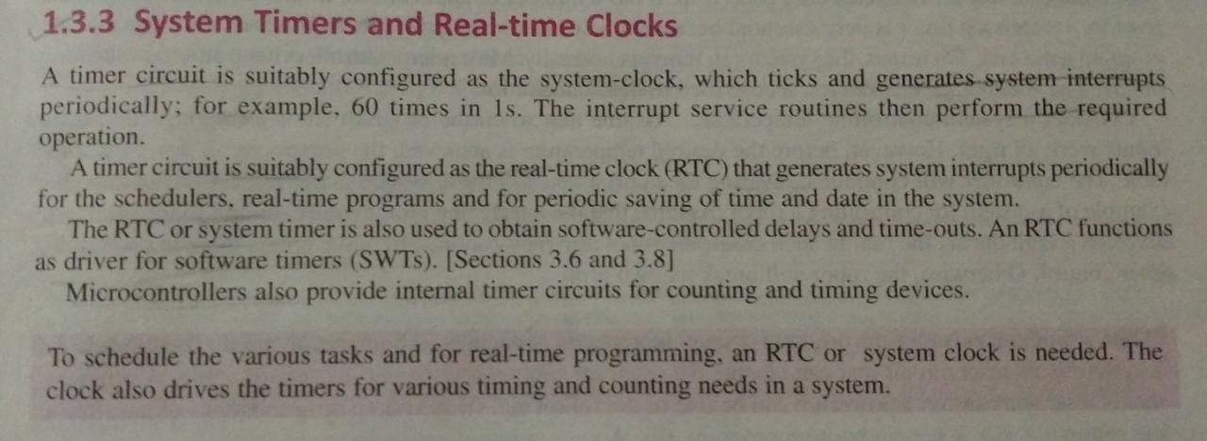

**Reset / Power Up**

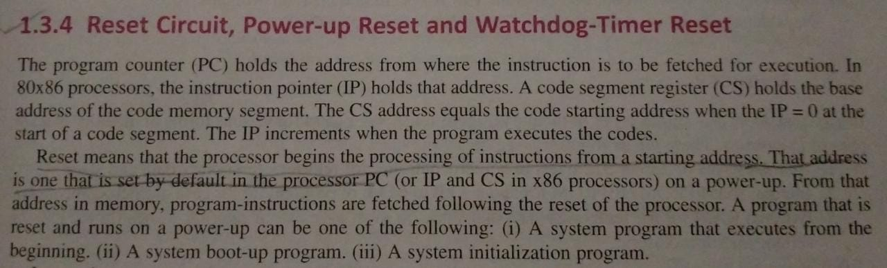

**Watchdog timer**

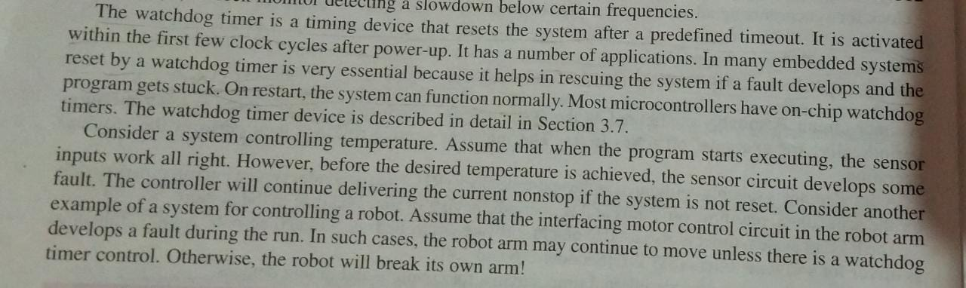

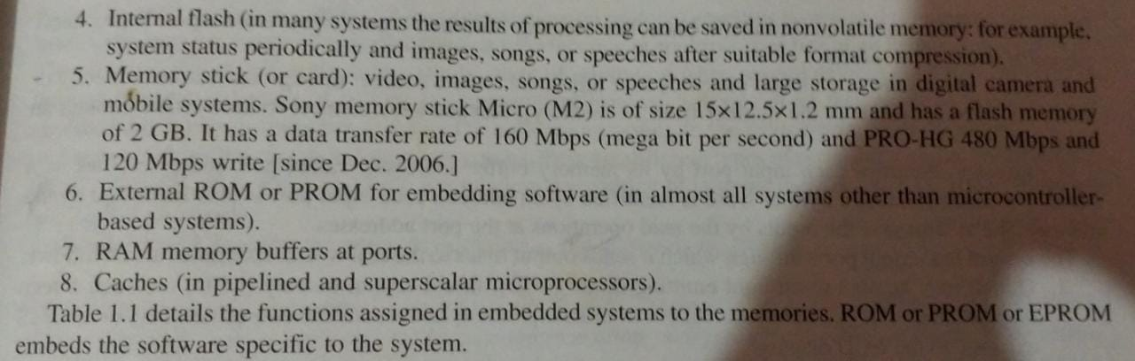

**Inputs / Input Ports**

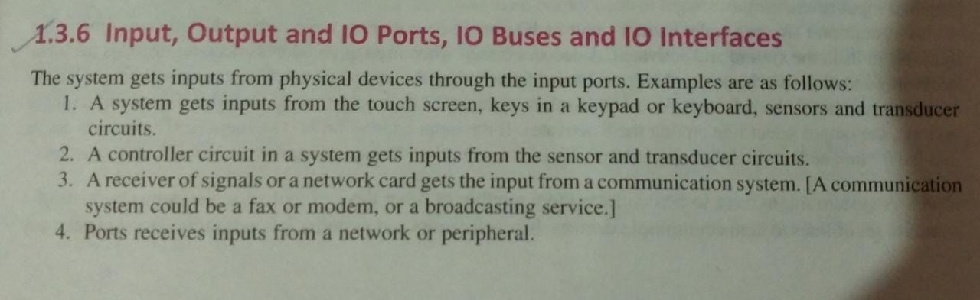

**Output / Output Ports**

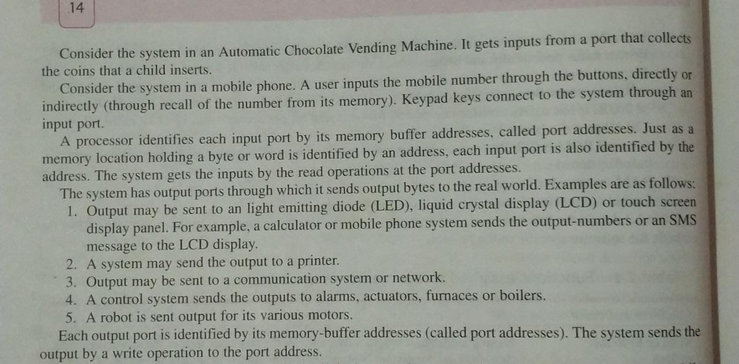

**General Purpose Ports**

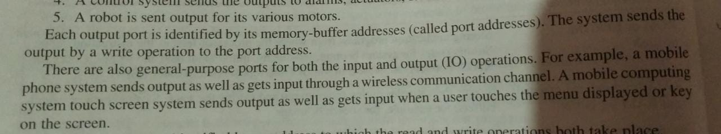

**Characteristics of ES**

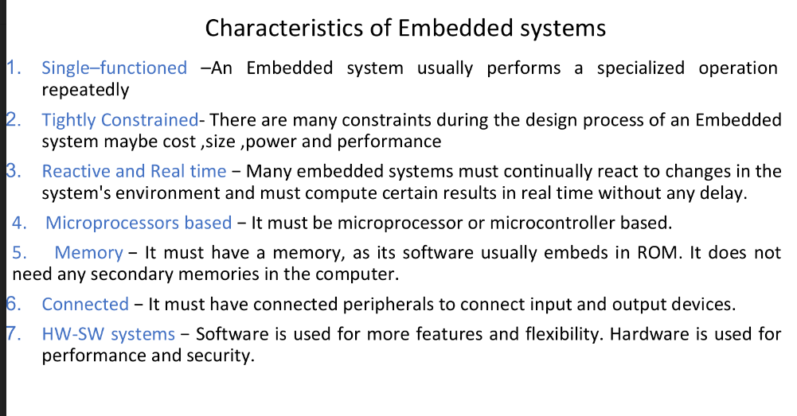

**Design Matrix of ES**

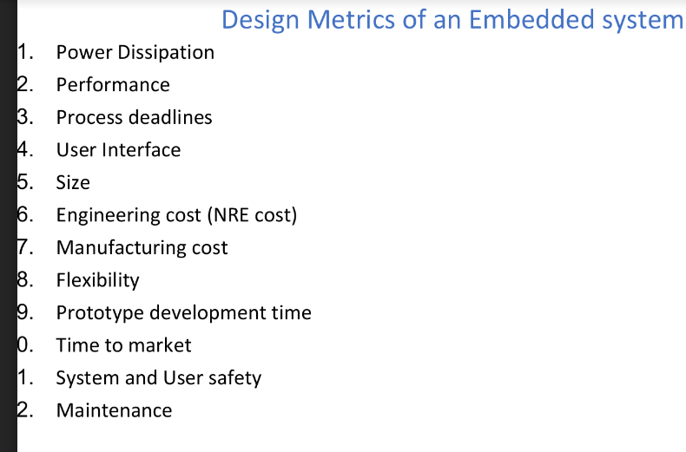

**Some important links to refer**

[Link 1](https://studytronics.weebly.com/design-metrics.html)

**i)** **Power Dissipation:** For many systems power consumption is an important feature. The battery needs to be recharged less frequently if power dissipation is small.

**ii) Performance:** Instruction’s execution time in the system measures performance. Smaller execution time means higher performance.

**iii) Process deadlines:** There are number of processes in the system. They have deadlines within which each of them have to complete the computations and give the result.

**iv) User interfaces:** These include keyboard GUIs and VUIs.

**v) Size:** Size of system measured in terms of physical space required, RAM in KB and internal memory in MB or GB and number of million logic gates in hardware.

**vi) Engineering cost:** (one time non-recurring cost) Engineering cost is the initial cost of developing. Also the cost involved in debugging and testing hardware and software.

**vii) Manufacturing cost:** (recurring cost) This includes the cost of manufacturing each unit.

**viii) Flexibility:** Flexibility in design enables development of different versions of a product and advanced versions later on, without any significant engineering cost.

**ix) Prototype development time:** Time taken is days or months for developing the prototype and in-house testing of system functionalities.

**x) Time to market:** Time taken in days or months after prototype development to put a product for users and consumers is the time taken for marketing.

**xi) System and user safety:** System safety comes into picture during accidental fall from hand or theft. User safety comes while using the product.

**xii) Maintenance:** Maintenance means changeability and addition to the system i.e adding or updating software, data and hardware.